Junit Testing Manual for ELITE Program
Junit

Framework used to test code
Shows test progress in a bar green(test is done correctly)
Provides Annotation and Assertion
Unit Testing -Testing single entity(class or method)

Features of Junit

  - Assertions for testing expected results,
  - Fixtures for sharing common test data,
  - Runners for running tests.

Example

Create a calculater class which can perform 4 basic operations

1.Addition
2.subtraction
3.Multiplication
4.Division

Step 1:

Create a Calculator class in Eclipse with the following methods

public class Calculator {

public double add(double a, double b) {
return a + b;
}

public double subtract(double a, double b) {
return a - b;
}

public double multiply(double a, double b) {
return a * b;
}

public double divide(double a, double b) {
if(b == 0) {
throw new ArithmeticException();
}
return a / b;
}

}

Step 2:

Now right click on the Calculator class in the eclipse project explorer and select JUnit Test case. If you don't this option, then select New --> Other... --> Java --> Junit --> JUnit Test Case.

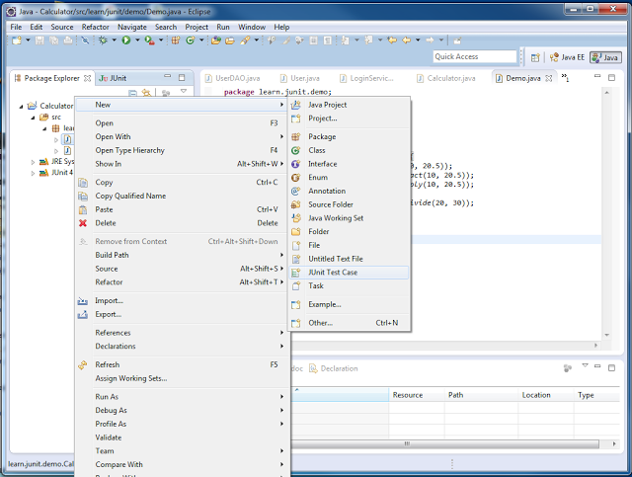

Step 3:

Enter the name of the test case file, package where it has to be create and also select the setUp() and tearDown() methods if required and click on next.

Step 4:

Select the methods you want to test and click on finish

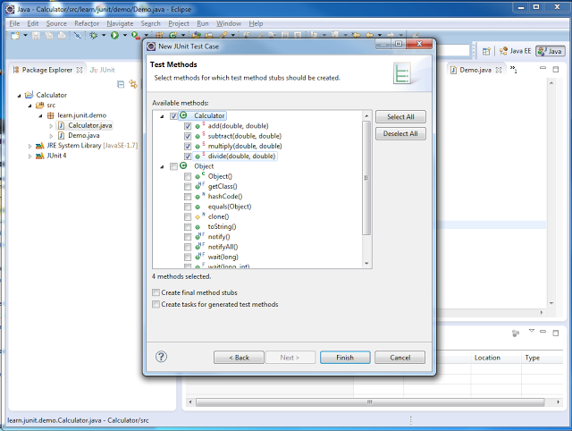

Step 5:

Now you get a list of test cases, one each for the methods you have implemented in the Calculator class. Now you can write your test cases and execute them.

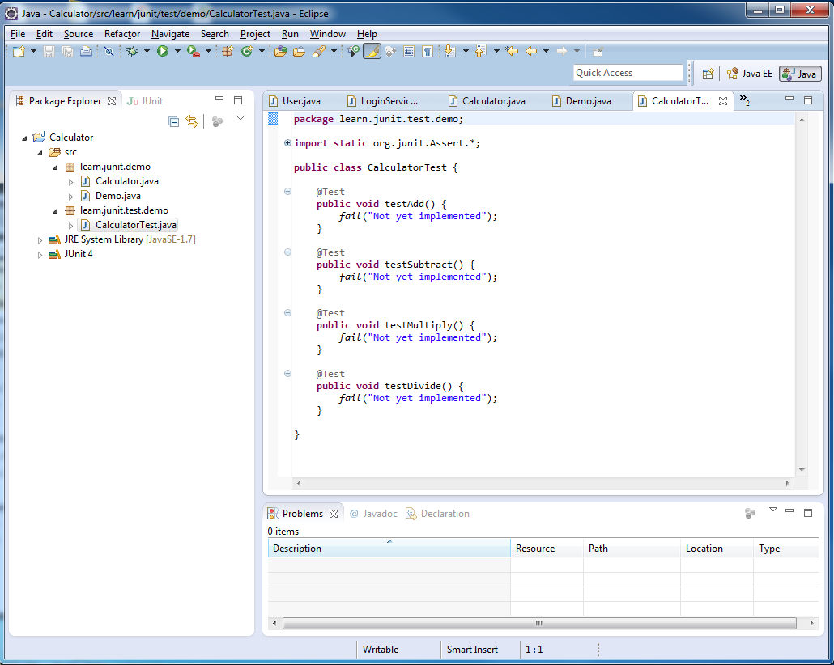

Step 6:

Just copy paste the implementation given below

import static org.junit.Assert.*;
import org.junit.After;
import org.junit.Before;
import org.junit.Test;

//Note: org.junit .*; Provides JUnit core classes and annotations.

public class CalculatorTest {

private Calculator calc;

@Before
public void setUp() throws Exception {
calc = new Calculator();
}

@After
public void tearDown() throws Exception {
calc = null;
}

@Test
public void testAdd() {
double result = calc.add(10.5, 20.32);
assertEquals(30.82, result, 0);
}

@Test
public void testSubtract() {
double result = calc.subtract(100.5, 100);
assertEquals(0.5, result, 0);
}

@Test
public void testMultiply() {
double result = calc.multiply(2.5, 100);
assertEquals(250, result, 0);
}

@Test
public void testDivide() {
double result = calc.divide(100, 10);
assertEquals(10, result, 0.001);

}

@Test(expected = ArithmeticException.class)
public void testDivideByZero() {
calc.divide(100.5, 0);
}

}

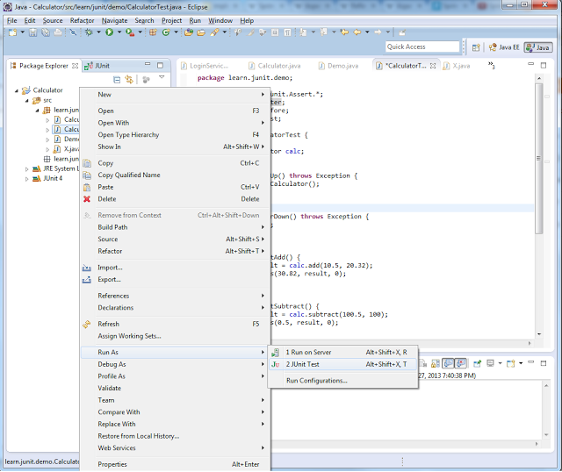

Step 7

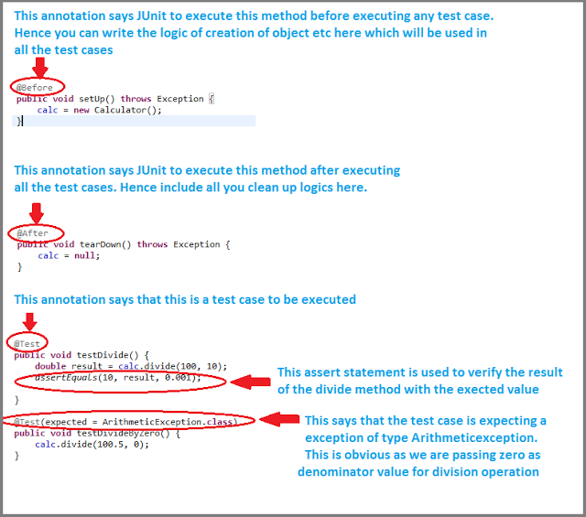

Annotation | Description
@Test | Annotates a method as a JUnit test method. The method should be of public scope and have void return type.
@Before | Marks a method to run before every test method. Useful for setting up test fixtures. The @Before method of a superclass is run before the current class.
@After | Marks a method to be run after every test method. Useful for tearing down test fixtures. The @After method of a superclass is run before the current class.
@Ignore | Marks a method to be ignored during test runs. This helps avoid the need for commenting half-baked test methods.
@BeforeClass | Annotates a method to run before any test method is run. For a test case, the method is run only once and can be used to provide class level setup work.
@AfterClass | Annotates a method to run after all the test methods are run. This can be useful for performing any cleanups at a class level.
@RunWith | Specifies the class that is used to run the JUnit test case.

Example 2:

FindOdd.java

public class FindOdd{

public static boolean isOdd(int value){
return(value%2==1);
}

Test class
------------
import static org.junit.Assert.assertFalse;
import static org.junit.Assert.assertTrue;

public class FindOddTest{

public void testOdd(){
assertTrue(FindOdd.isOdd(3));
assertFalse(FindOdd.isOdd(2));
}

Example 3:

public class JunitTest{

public String concatenate(String one,String two)
{

return one+two;
}

public int multiply(int number1, int number2)
{
return number1*number2;
}

public class ConcateTest{

public void testConcate(){
Junit test=new Junit();
String result=test.concatenate("one","two");
assertEquals("onetwo",result);
}
}

public class MultiplyTest{

public void testMultiply(){
Junit test=new Junit();
int result=test.multiply(3,4);
assertEquals(12,result);
}
}

